## Flutter installation and setup:

*First of all, use the following cmd to check whether flutter is installed in our system or not, for that open "command prompt" from your system and write:*

*flutter*

*Or else write:*

*flutter version*

*If it'ould have been already installed in our system, then it'll show a positive output and if isn't then it'll show following output:*

*'flutter' is not recognized as an internal or external command, operable program or batch file*

***First of all, download Flutter from:***

[*https://flutter.dev/*](https://flutter.dev/)

***Visual studio code from:***

[*https://visualstudio.microsoft.com/*](https://visualstudio.microsoft.com/)

***And android studio from:***

[*https://developer.android.com/studiohttps://developer.android.com/studio*](https://developer.android.com/studio)

*Installing android studio will automatically install SDK and then after, manually, we don't have to install then. We'll not use android studio for coding, because it uses javascript. It's just an IDE where we can write and execute codes. IDE gives us a text editor , so that we can write and compile code without using another text editor. Whatever path we select to install SDK, be ensured that it doesn't contain any space, like: "c:\users\public\flutter class\ "in this case the space which is given btw "flutter class" should not be given, else, it'll interrupt in installing.*

*After extracting flutter from zip/rar, we've to provide the location to it, for this just follow the steps, first of all search an open "edit the system and environment variable"*

*Just go to "Environment Variables":*

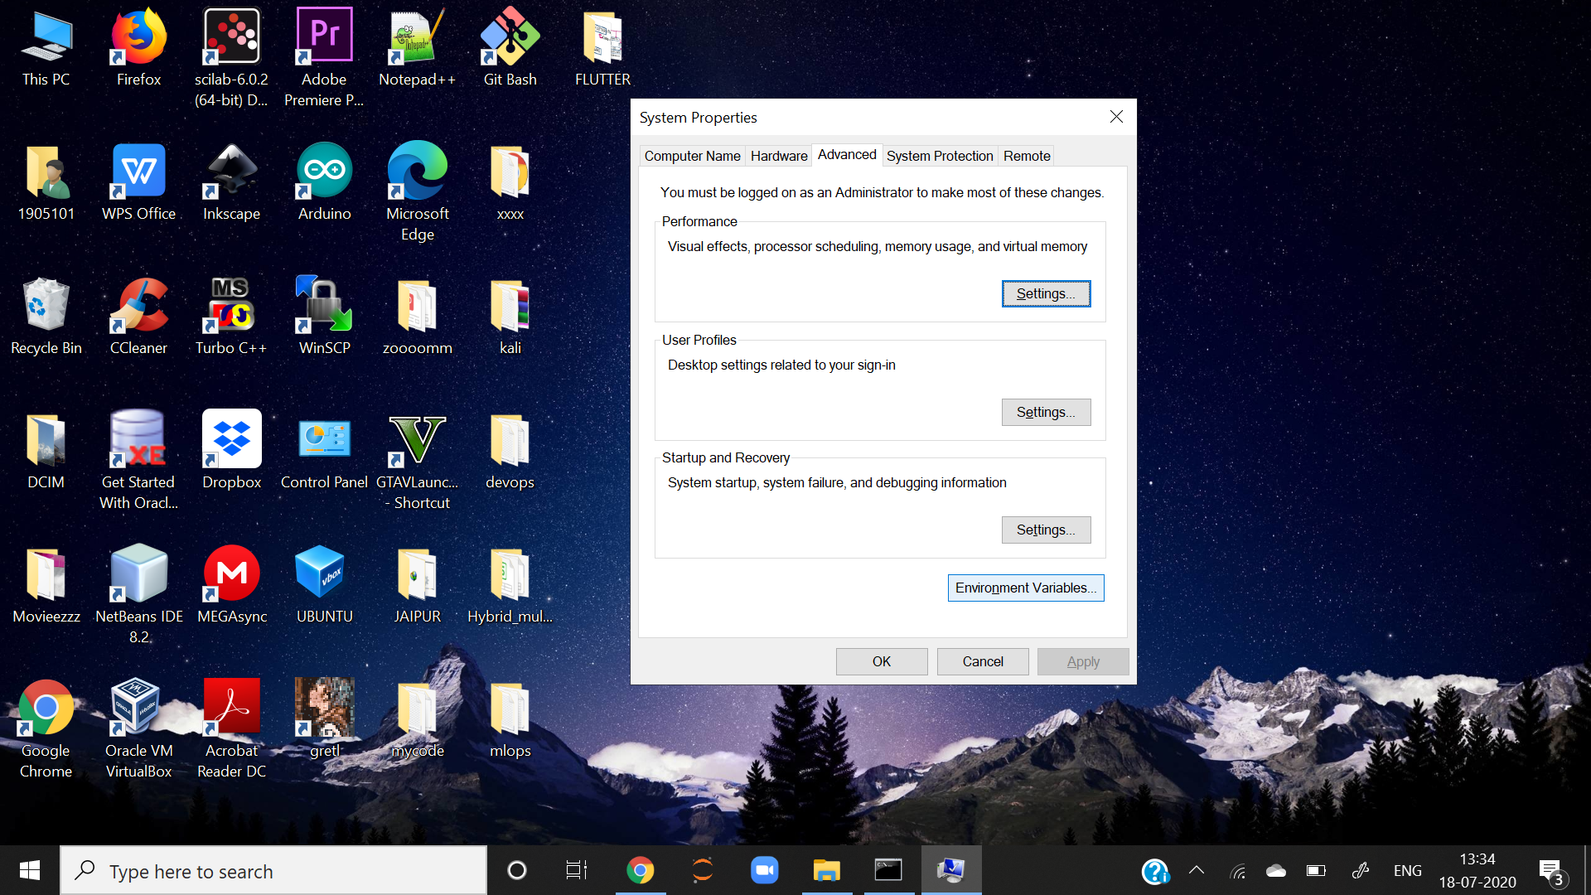

*In the below picture, just click on "PATH"and then "EDIT":*

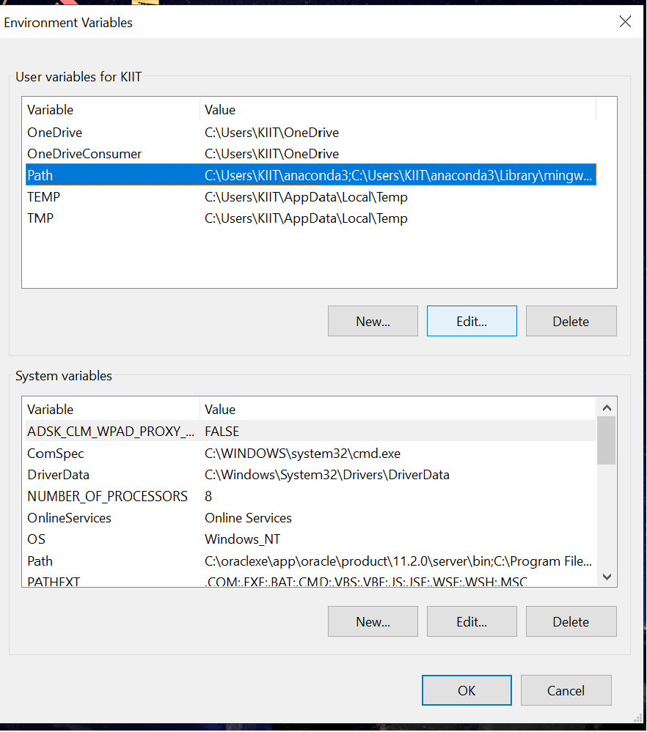

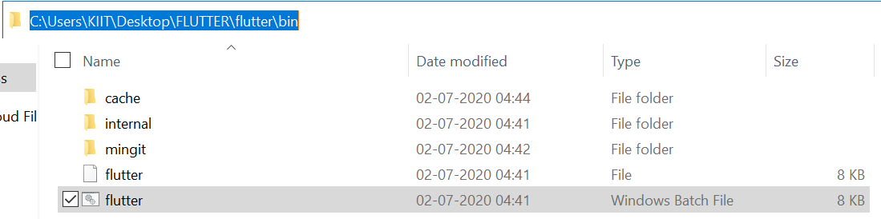

*Now, go to the location where we've extracted the flutter and open "bin" and then select the path, as shown above.*

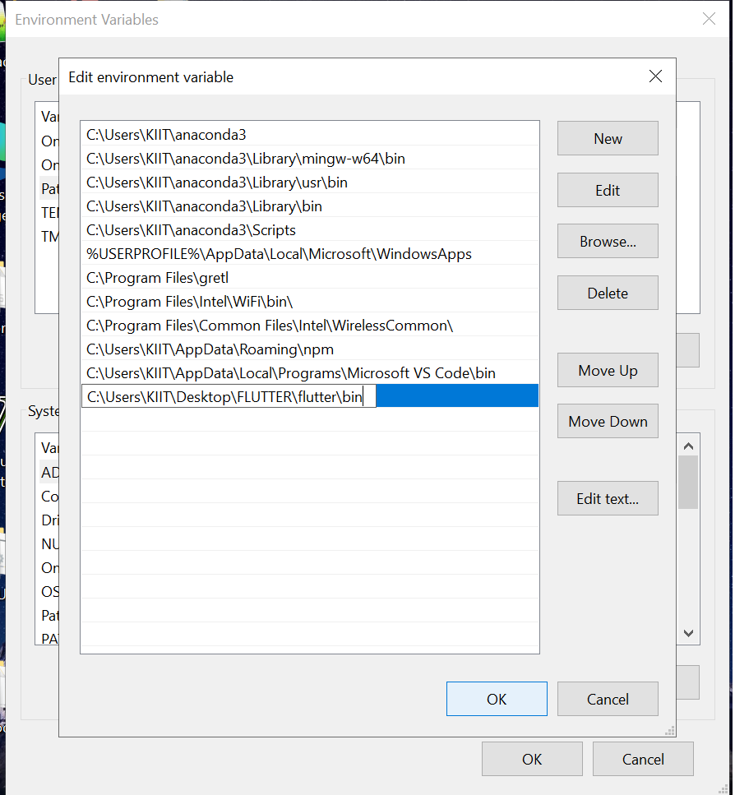

*Add a new path or paste that location which we earlier copied and then click ok and save all.*

*After all these, when again we'll go to cmd prompt (be ensured it is newly opened) and write "flutter" or "flutter version" then it will give following response:*

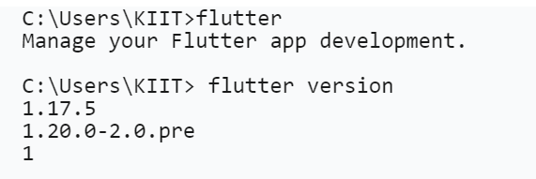

*Hence, here we successfully installed Flutter.*

## Android studio installation and setup:

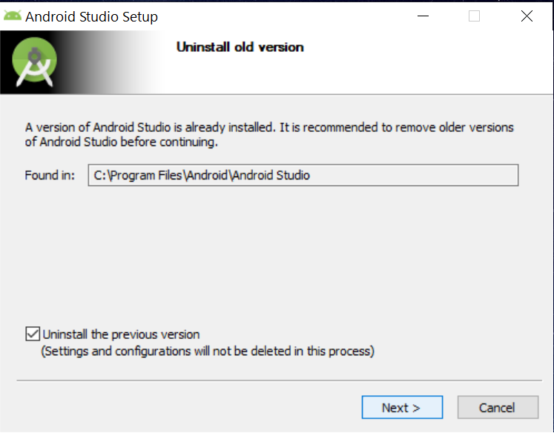 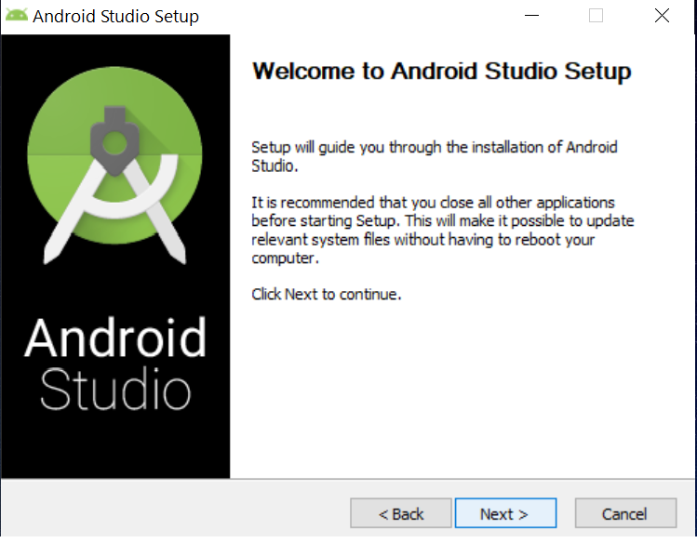

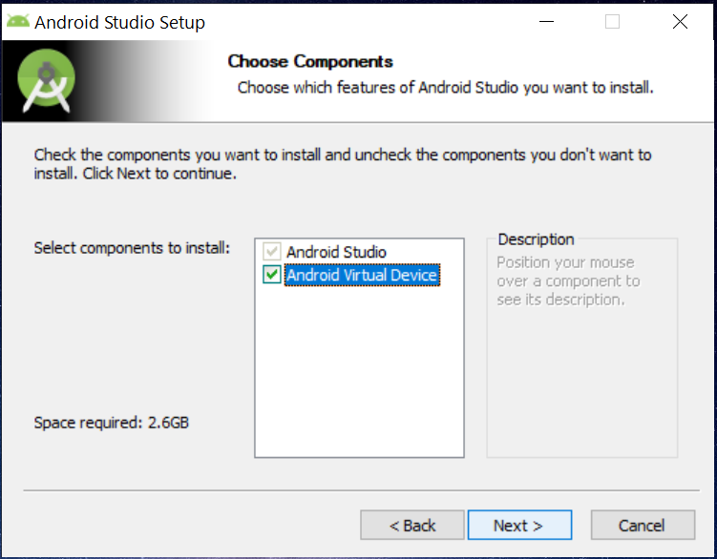 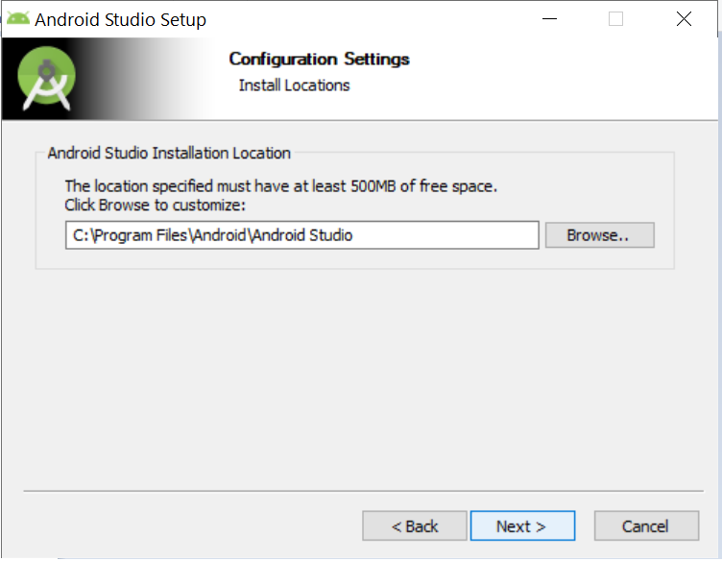

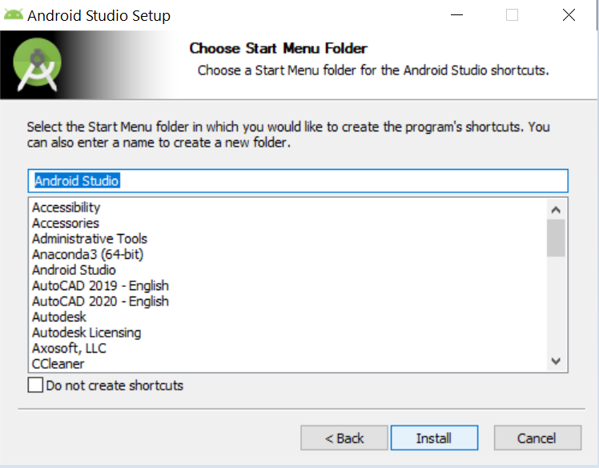 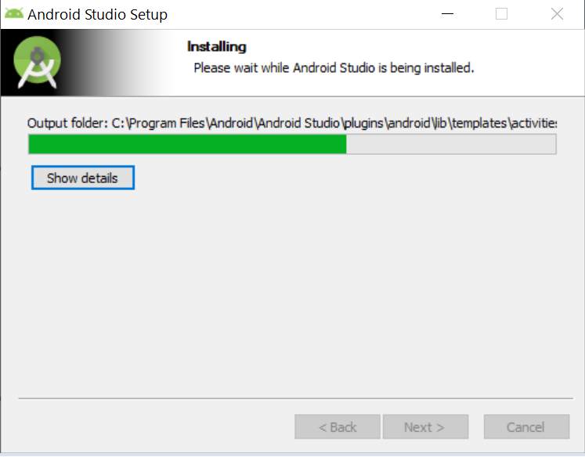

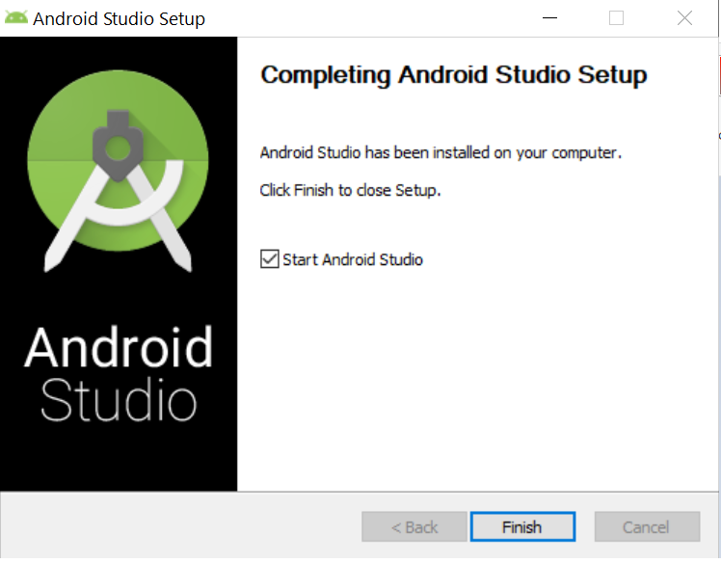 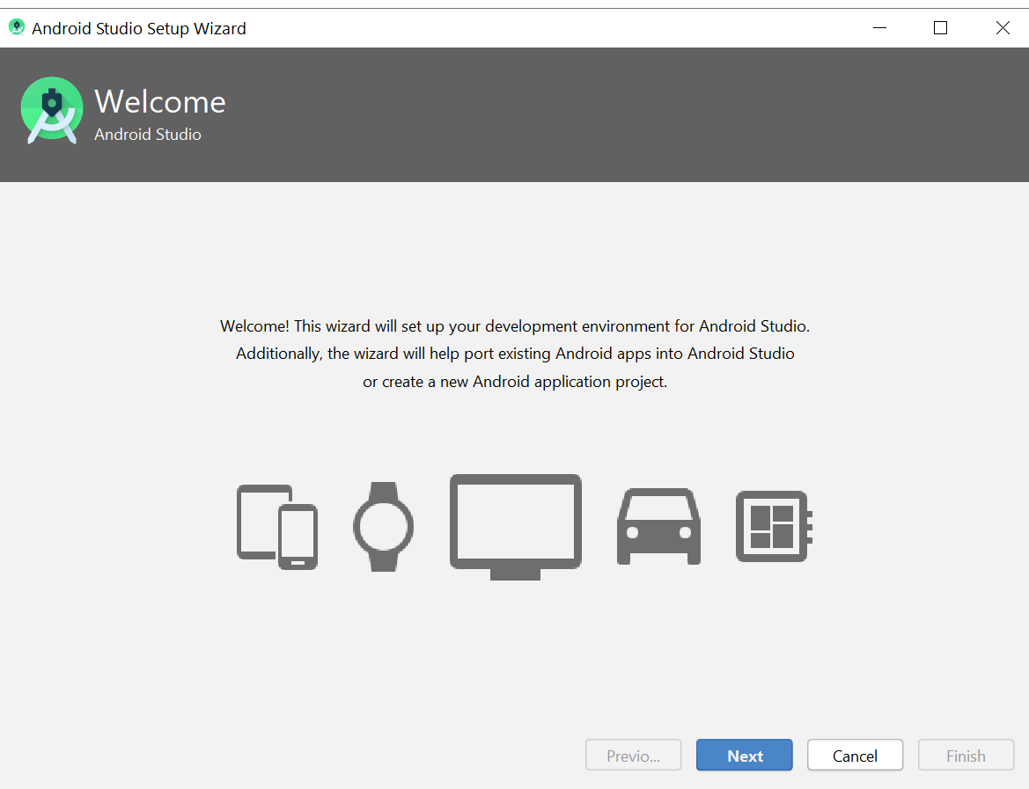

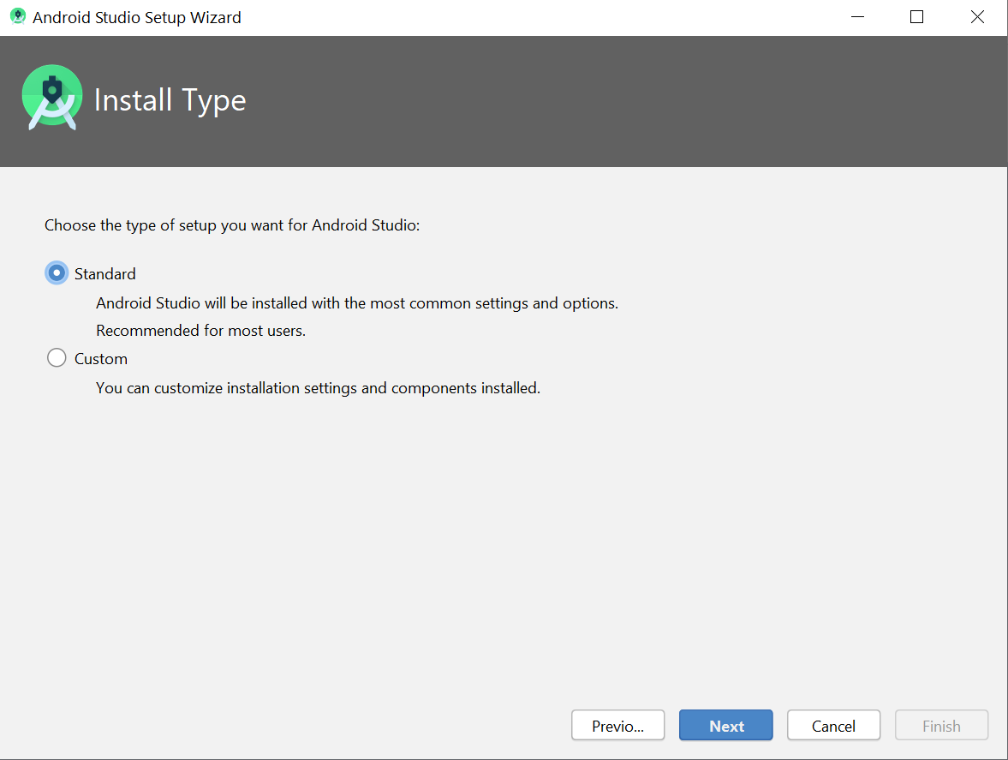 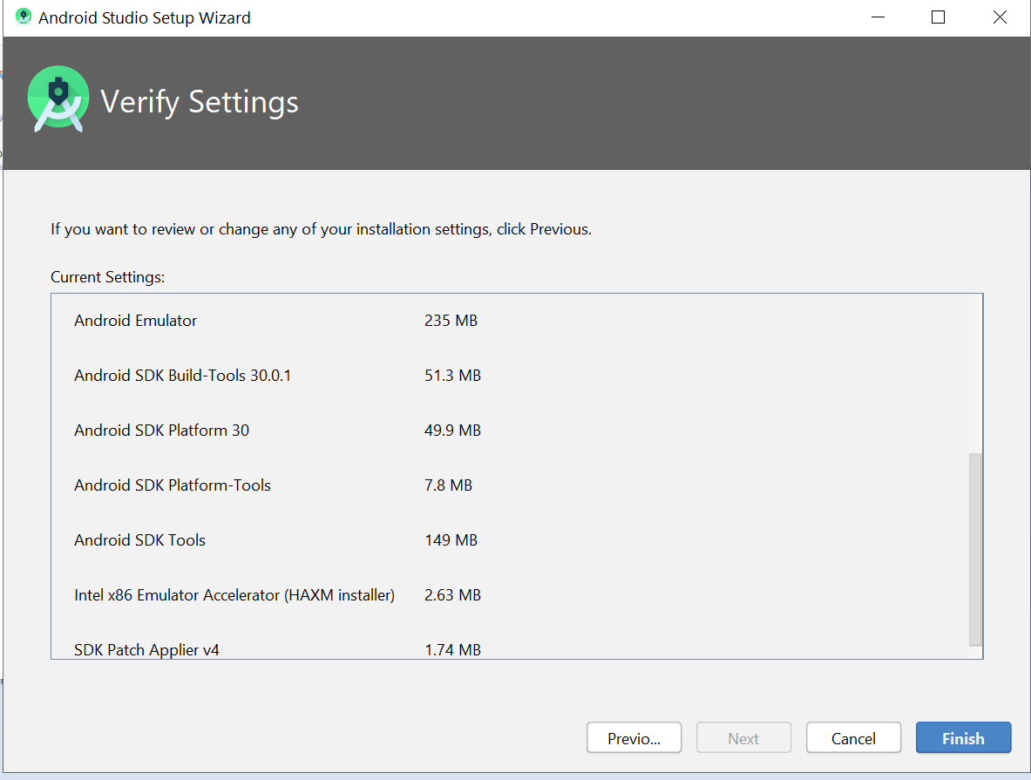

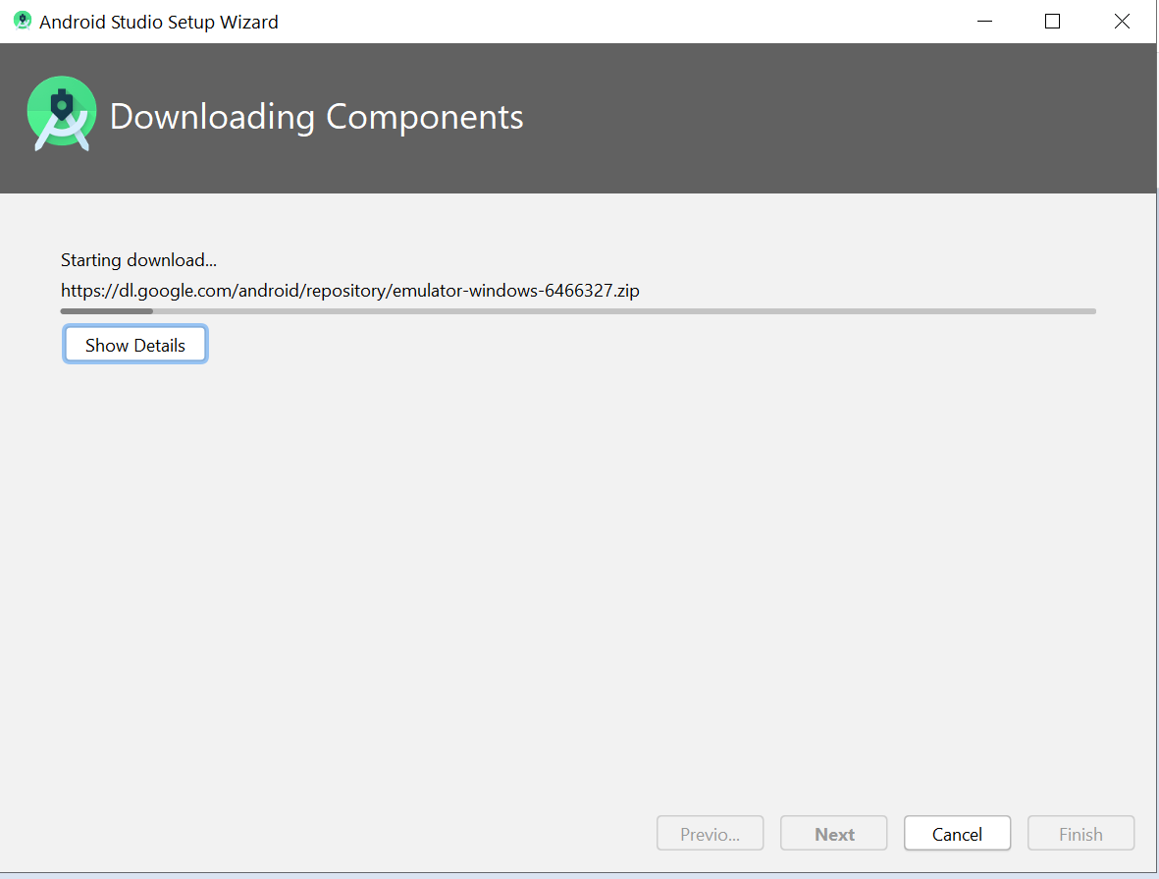 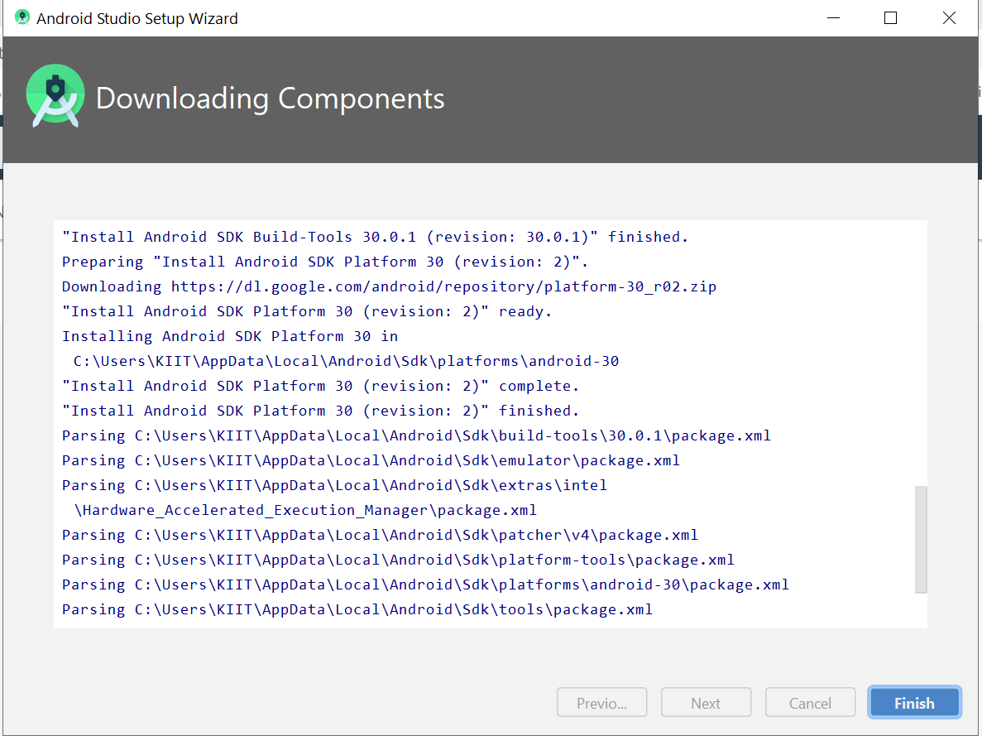

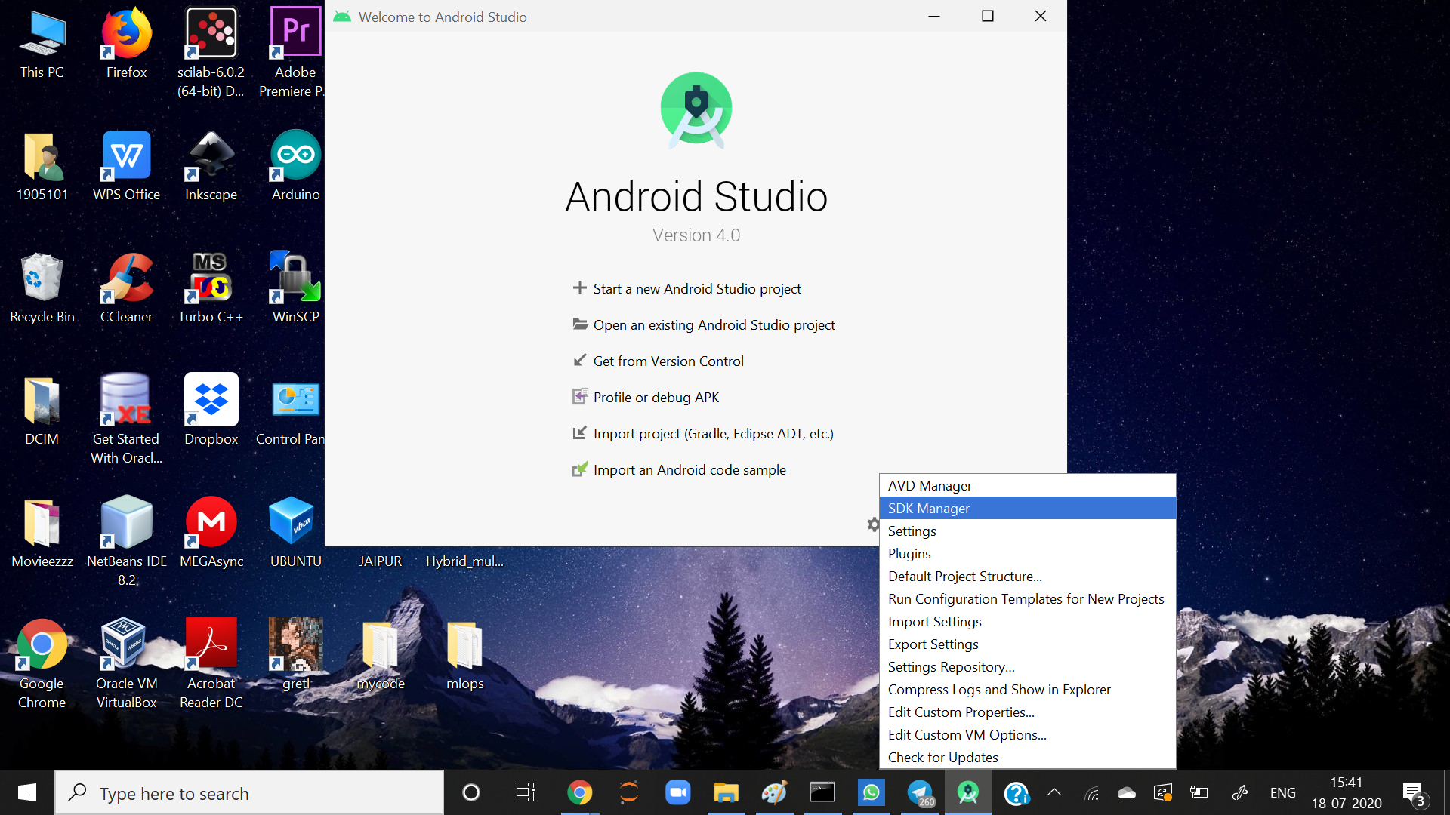

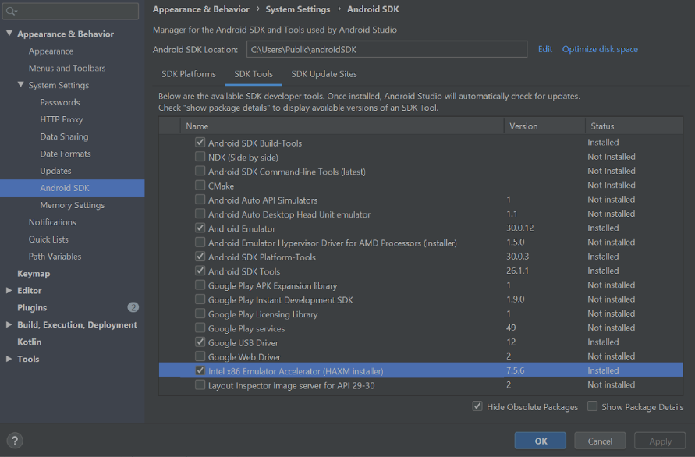

*Now, after we set upped our SDK, then we'll further move to AVD, for that we again've to first set up path in environment variables.*

*For that, just again go to environment variable and follow the steps as shown.Go to new user variable, and set variable name as ANDROID_SDK_ROOT and variable value as the location where we've saved our android studio.*

*Then click OK and save the changes.*

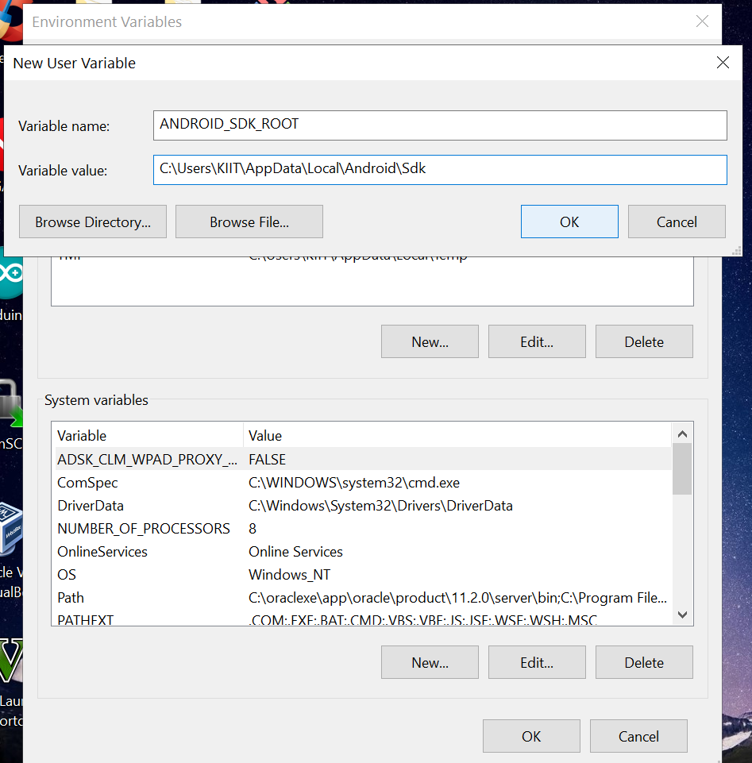

*After adding new variable and saving it, our variable name and it's value will be shown.*

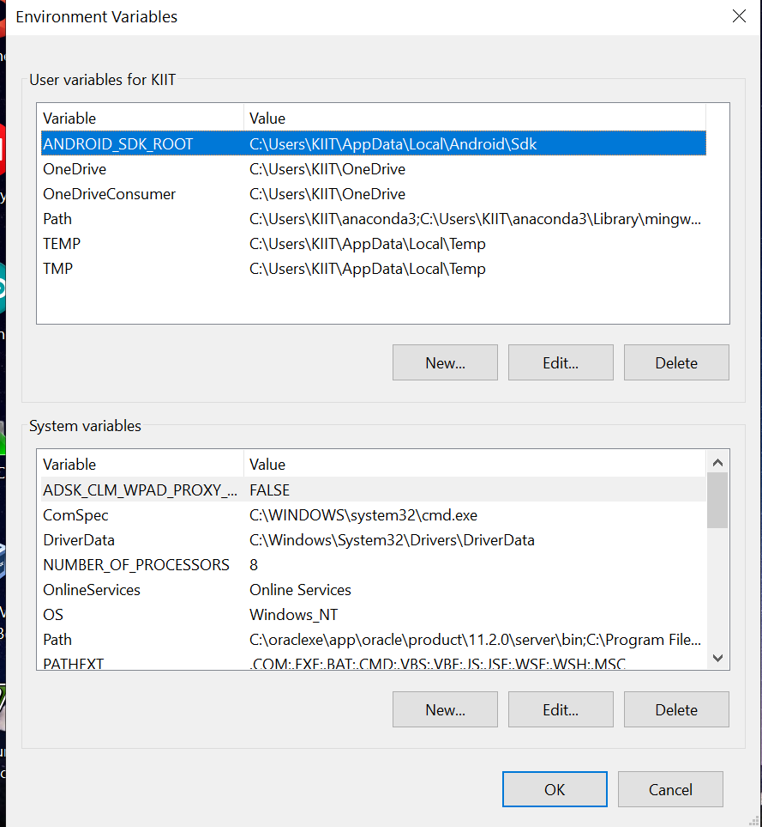

*Now, to launch AVD, just follow the steps:*

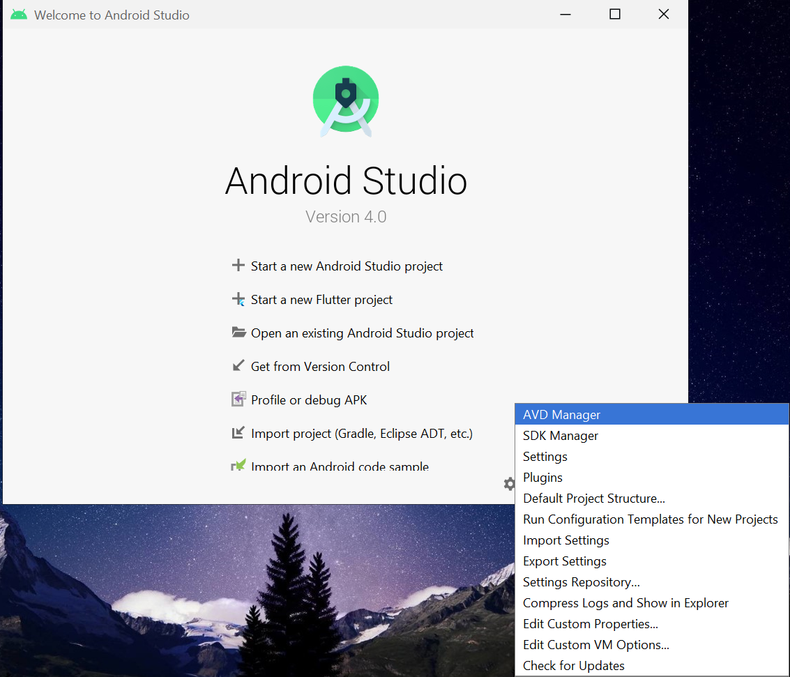 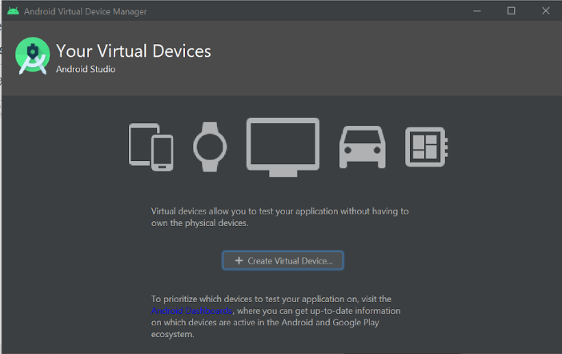

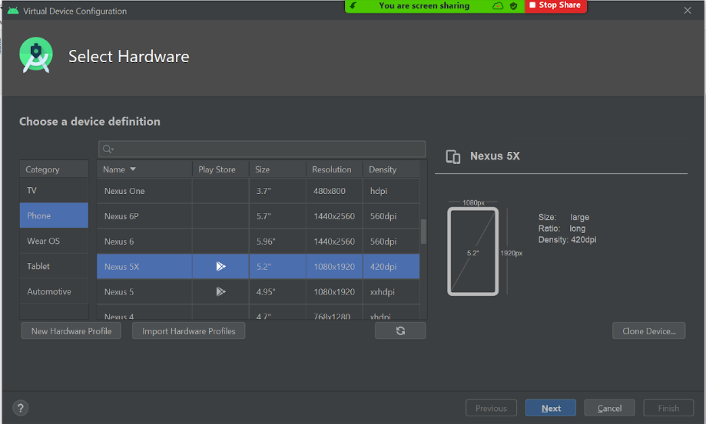

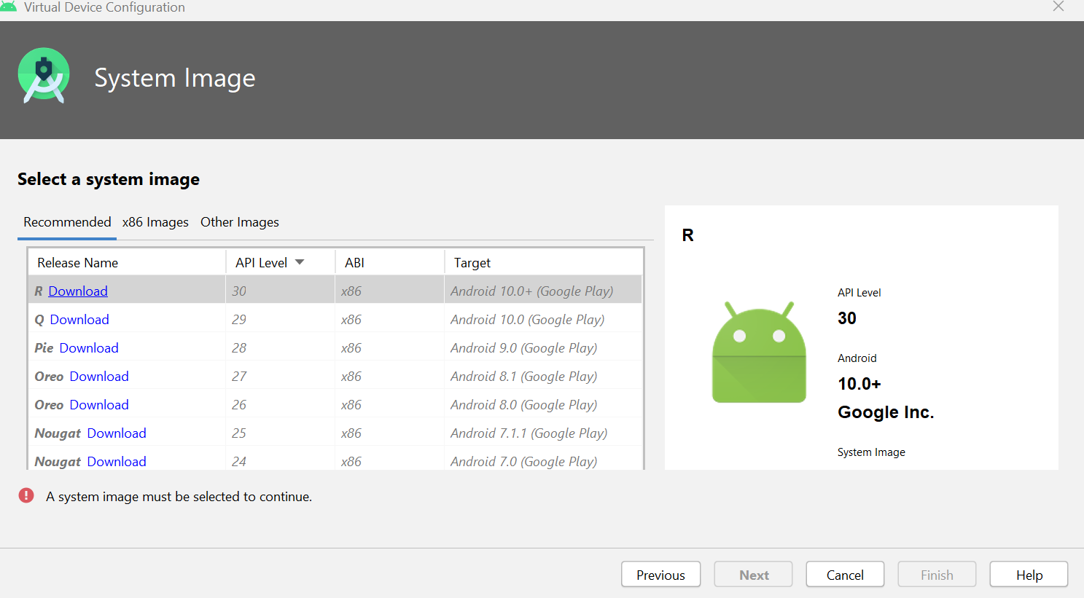

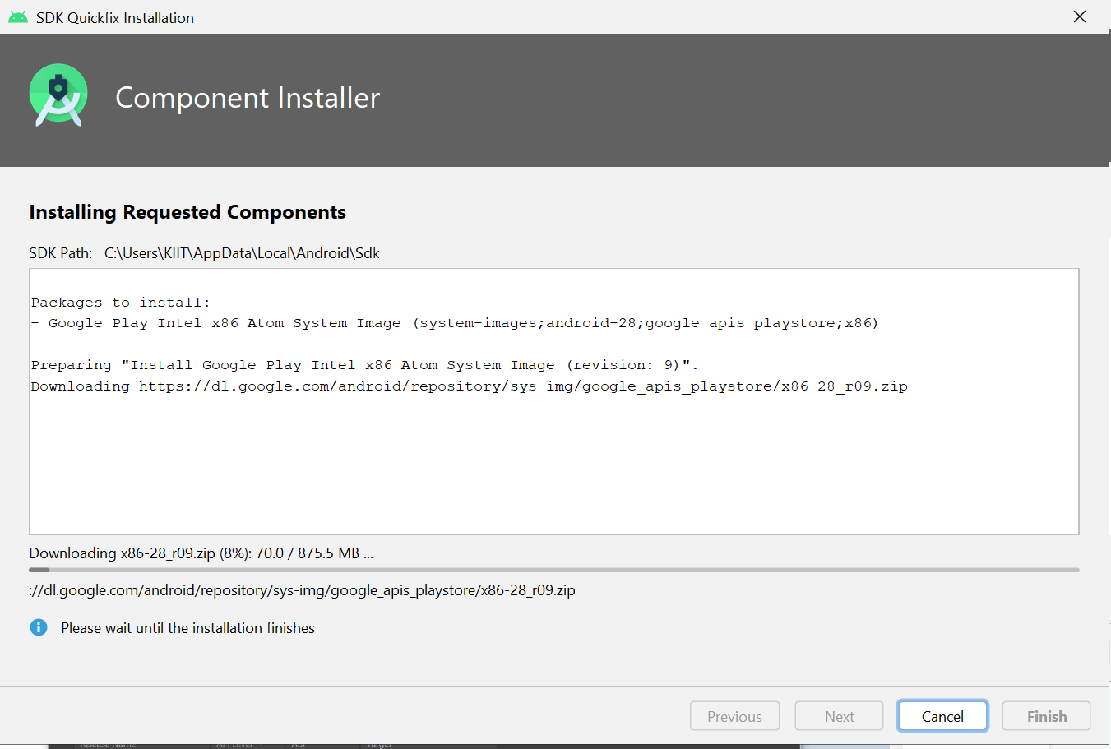

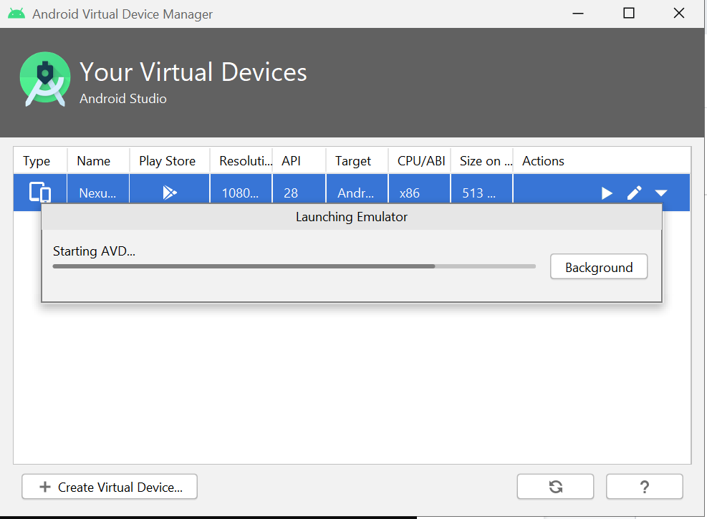 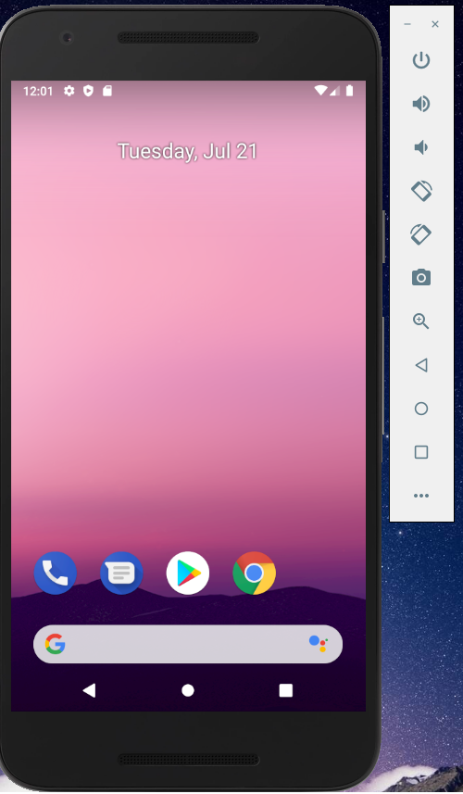

*And now our virtual mobile will be launched as shown in the picture.*

## VScode Installation:

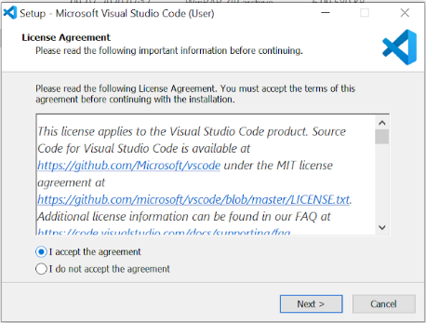 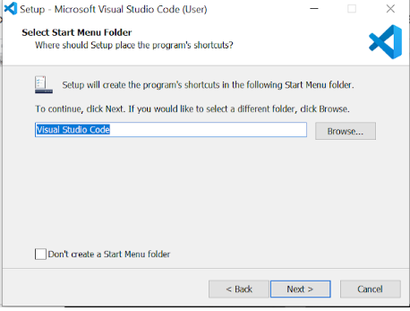

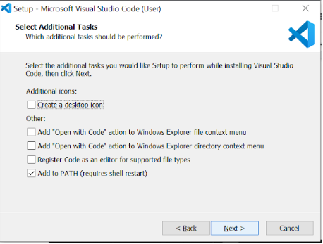

*Now after that, visual studio has been successfully installed, we'll now test a program. For that, we'll just launch our emulator either using AVD or either by cmd prompt line using the command:*

*flutter emulators --launch Nexus_5X_API_28_CLASSROOM_FLUTTER*

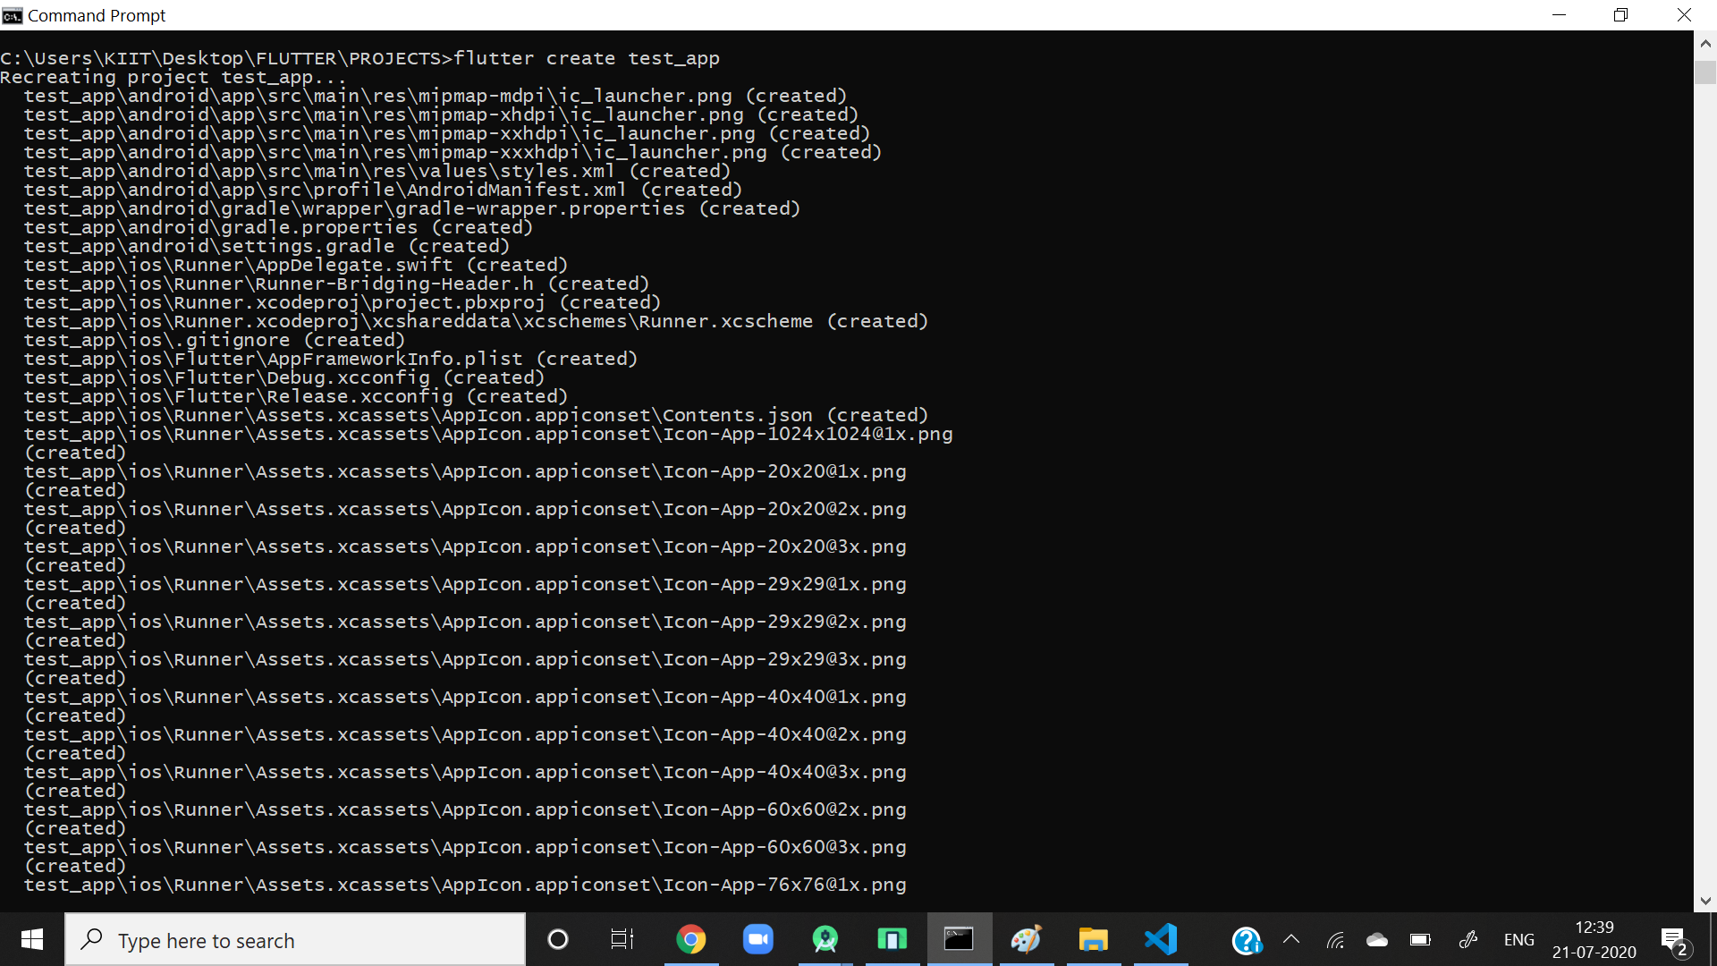

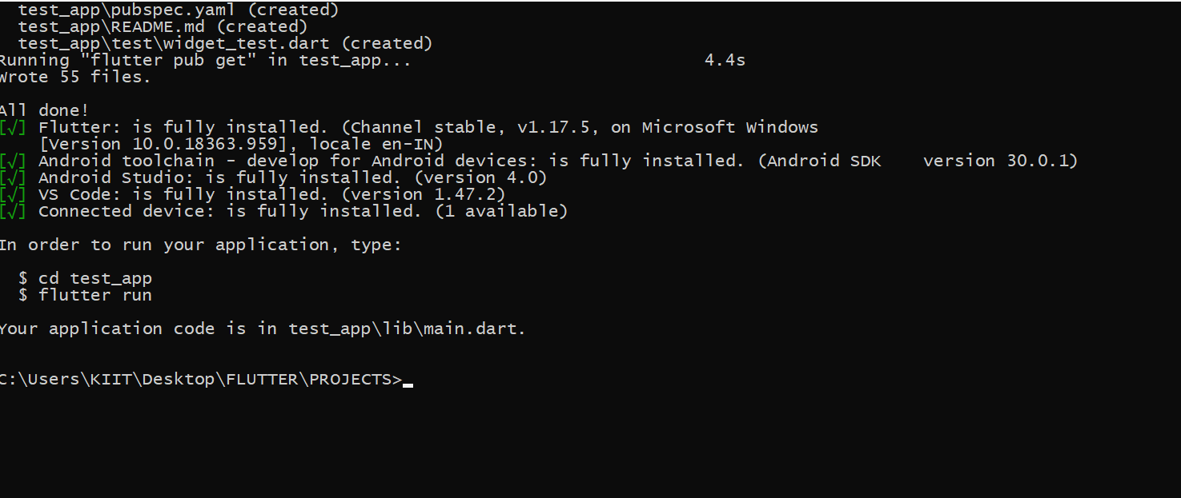

*And here we successfully created our test_app, in which we'll test code and run it in emulator.*

*NOTE: install flutter and dart plugin in visual code studio*

*Now, open visual studio code and go to FILE>OPEN FOLDER*

*Choose the folder where you've saved your test_app in my case it was saved inside project.*

